Settings:
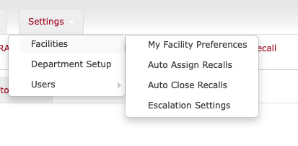

MD Buyline has an option to “Auto Assign Recalls”. That’s what we are planning to do with every recall. Apparently, organizations need the flexibility to turn auto-assign on and off. Mount Sinai does not have auto-assign on currently because I have to double-check all of their work. We will be right every time, and deliver to the correct department every time using their POH data.
Auto-close for MD Buyline means that when all facilities have entered data, and a comment is entered, the recall automatically closes. Mount Sinai has it on, otherwise recall have to be closed manually, by another person.


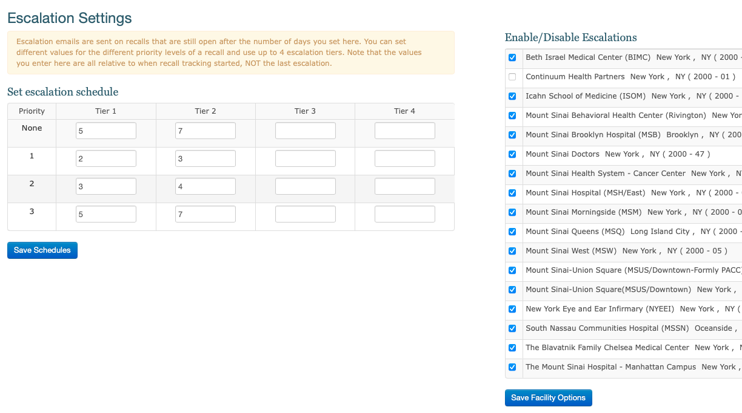

Escalation Email Sample from MD Buyline.
I receive such poor responses to this email below. It is very bland. The report that is attached is terrible. Our snapshot is MUCH better.
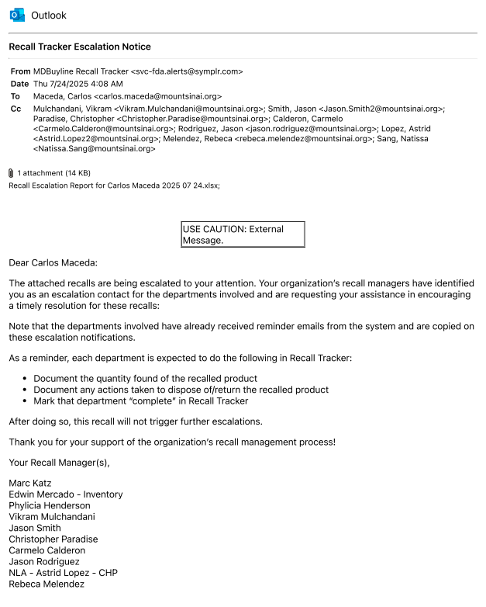

Escalation Settings:
Esclations can be customized based on facility and/or department, or by entire organization. Different people at different facilities could be tier 1 and tier 2. Mount Sinai happens to have 2 people for all 17 locations.
